[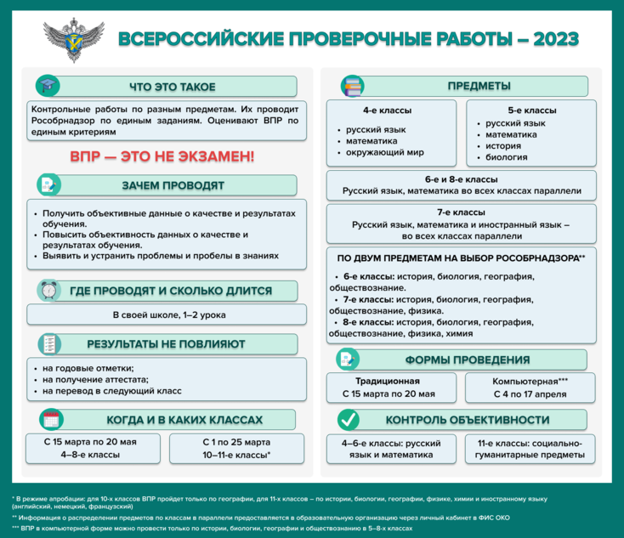](https://supervip.1zavuch.ru/system/content/attachment/1/16/-425860/?isInline=true)